**  
Sierra-Olympia Technologies Inc.

Scott Vosburgh

(541)716-0015

[marketing@sierraolympia.com](mailto:marketing@sierraolympia.com)

**Release Date:**

9/12/24

**INTRODUCING THE VINDEN 75T**

**Hood River, Oregon, September 12, 2024** - Sierra-Olympia Technologies, a leading innovator in thermal imaging solutions, is thrilled to announce the release of the Vinden 75T. This LWIR infrared camera packages a state of the art DRS Tenum 640, 10 micron core with high performance continuous zoom optic.

Built around an industry leading 10-micron pixel pitch camera core from Leonardo DRS, the Vinden 75T boasts a 640 x 512 array format with the options to connect via USB, SDI and MIPI outputs.

**Key Features and Benefits:**

* 5X Continuous Zoom with Electronic Focus
* 10 Micron LWIR Sensor
* Onboard Contrast Enhancement
* 60Hz Frame Rate

To learn more about the Vinden 75T thermal camera and explore its capabilities, visit the product page at [https://sierraolympia.com/product/vinden-75t](https://sierraolympia.com/product/vinden-75t/). For media inquiries, please contact Scott Vosburgh at [marketing@sierraolympia.com](mailto:marketing@sierraolympia.com).

**About Sierra-Olympia Technologies:**  
Sierra-Olympia Technologies is a leading provider of cutting-edge thermal imaging solutions. Committed to innovation and excellence, Sierra-Olympia Technologies develops advanced thermal cameras that empower professionals across various industries to overcome challenges, increase efficiency, and enhance safety. With a focus on exceptional quality and customer satisfaction, Sierra-Olympia Technologies is dedicated to driving advancements in thermal imaging technology.

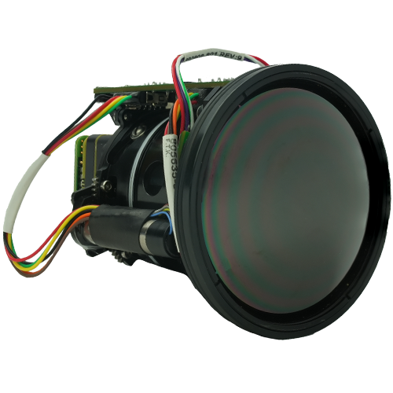

Figure : Official product Image of Vinden 75T



Figure : Vinden 75T Screen Grab. Filming bridge at distance of 1.5km